Introduction

Glaciers are sensitive to climate change. The climate feedback mechanism, referred as instantaneous glacierization, increases the rate of snow accumulation when temperatures cools down (Koerner, 1980). The accumulation of snow cover increases the surface albedo locally, so the solar radiation absorption contributed to the local climate is reduced, which stimulates the generation of new glaciers and ice sheets. In a marine based model, the sequence of glaciation starts from the generation of permanent sea ice to the glaciation of inter-island channels, which is referred as marine ice transgression hypothesis (Denton & Hughes, 1981). The cooldown of temperature first thickens fast ices into ice shelves, which will develop into a marine ice dome, the ice dome increases the reflection rate so that the glaciers will continue to grow through instantaneous glacierization. On the other hand, when temperature increases, the melt of sea ice and glaciers exposes bedrocks and water to the sun, so solar radiation absorption rate will increase (Benn & Evans, 2014). The ice-albedo feedback triggers further melt of glaciers and sea ice. Therefore, the retreat of glaciers is a sensitive indicator of climate change.

The retreat of glacier terminus has two different patterns. The glaciers terminated on land retreats according to the rate of surface melt, but the glaciers terminated in the ocean retreats according to internal ice dynamics like flowing and calving (Abdalati et al., 2001). Marine terminating glaciers are originated from either land accumulation or bottom accretion (Lemmen, 1988). The floatation of glacier tongues creates glacier ice shelves, and the freezing of surface sea water generates sea-ice ice shelves. The combined mechanism will generate composite ice shelves.

The study area of glacier extent monitoring is Northeast Greenland Ice Stream (NEGIS). NEGIS is a 600 km ice stream that drains the interior ice sheets via three meltwater glaciers. The northern Greenland ice sheet used to be stable in the past centuries, but it became unstable and started to lose mass in the last decade (Gramling & Carolyn, 2015). The outlet glaciers Zachariae Isstrøm (ZI) and Nioghalvfjerdsfjord Gletscher (NG) in NEGIS broke their equilibrium states by accelerations or retreats between 2006 and 2012, but the glacier Storstrømmen Gletscher (SG) remained stable (Larsen et al., 2018). ZI tripled its velocity in 2012, which contributes huge amount of calving ices into the sea. According to modeling studies using different warming scenarios, ZI will continue to retreat towards 30 km upstream and contributes 16.2mm to sea level rise by 2100 (Larsen et al., 2018).

Ice calving is the main mechanism that causes the marine terminating glaciers in NEGIS to retreat, which contributes about 71% of the ablation (Wood et al., 2018). The ocean process like warmer ocean temperature and subtropical current mainly controls the calving of marine terminating glaciers (Sole et al., 2008). Moreover, many hypotheses have been proposed to explain the dynamics of glacial retreat to climate change. These analyses include differences in glacier/fjord geometry, atmospheric warming, subglacial discharge and ocean-induced warming (Wood et al., 2018).

Ocean temperature has strong influence on the retreat of glaciers in NEGIS. The warm water below the sea ice surface interact actively with the anchor points between ice and bedrock. The grounding line in NEGIS remains stable before 2012, but recently the water is warm enough to detach the glacier from the underwater sill (Gramling & Carolyn, 2015). Moreover, there is a sea floor basin with a deep channel in the fjord that connect to inland at the outlet glaciers of NEGIS. The sea floor basin and the channel will provide a path for warm water to continue to melt the glaciers even if they retreat to the edge of inland (Gramling & Carolyn, 2015). Therefore, the interaction between glacier and ocean temperature will be significant to investigate.

Monitoring the response of glacier extent to climate change strongly meets with the 13 Sustainable Development Goal. As the world is experiencing increase in sea levels and extreme weather conditions due to climate change, it is significant to examine the relationship between glacier retreat and climate change, which will provide valuable information for future sea level monitoring. The research will be a representative case of urgent action to combat climate change and its impacts.

Objective:

Identify the relationship between glacier retreat in NG and climate change.

Identify the relationship between terminus position in NG and ocean temperature.

Provide a method for long-term terminus monitoring.

Hypothesis:

Glacier retreat in NG is strongly related to climate change.

The retreat of terminus position in NG is positively related to the rise of ocean temperature.

Method

Due to the constraint of data availability, spatial resolution and efficiency, the glacier extent study will investigate the change of glacier extent in NG, NEGIS from May 2015 to March 2019 (Figure 1). The default map projection is WGS 84 / NSIDC EASE-Grid North. NG consists of two marine-terminating sub-flows, so two sets of data will be investigated. The northern outlet is named NG1 and the southern outlet is named NG2.

Sentinel-1 Level 1 C-band GRD SAR imagery is used for glacier boundary detection. Sentinel-1 is a C-band Synthetic Aperture Radar satellite imagery system. Sentinel-1’s Interferometric Wide (IW) swath mode acquires data with 5m * 20m spatial resolution with duel HH+HV, VV+VH polarization. Sentinel-1 data also features global coverage and a 12-day revisit time. The data is available from 2014 to present, and the available images will be aggregated by month. Therefore, 46 images from June 2015 to March 2019 will be used. The band HH will be used for the intensity value because it is the only available band for the study area within the time range.

In the area of NEGIS, the extent of a glacier is mainly determined by the terminus of the glacier. The edges that are parallel to the flowing direction of a glacier are considered unchanged during the short time interval between May 2018 and March 2019. Therefore, the boundary detection method will focus on detecting the change of terminus.

To detect the change of terminus in NG, a mesh consisting of 39800 points will be generated to extract the pixel values in the study area. First, the edges paralleled to the flowing direction of the glacier are digitized in ArcMap (Figure 2). Secondly, 200 points along the parallel edges with the same distance interval are generated using Construct Points in ArcMap (Figure 3). A field named “flowid” is added to the series of points, which indexes the location of points from 1 to 200 starting from the endpoint at the higher altitude. After that, 200 lines are generated between the two edges connecting the pairs of points with the same “flowid” using Points To Line tool from the ArcMap Data Management Toolbox (Figure 4). Next, 199 points with the same distance interval are generated along each of the 200 lines, and each of the points is indexed from 0 to 198 by a field called “pid”, which indicates the location from one edge to the other (Figure 5). In this way, the mesh with 39800 points indexed with “flowid” and “pid” as coordinates is finished. The average distance between adjacent points in each profile is around 101.3 m.

The mesh is uploaded to Google Earth Engine (GEE) for pixel value extraction, so each point will have an intensity value for each image. Therefore, 46 * 39800 points are generated and exported from GEE. The aggregation method for images in each month is ee.Reducer.median(), so the median pixel value of each month is used. A field called “newID” is added to index the images from 0 to 45. The script used for this process is shared here: <https://code.earthengine.google.com/9af061930686fc1c4bd6a091f567a896>.

After the pixel value extraction, the dataset is loaded in RStudio, and an R script (<https://github.com/eralogos/Terminus-detection/blob/master/Rdir/detection.R>) is used for detecting the terminus points in each image. First, the script loops through each “newID” from 0 to 45, so the whole dataset is separated by image indexes. Secondly, for each image index, the “pid” loops from 0 to 198 to retrieve the profiles. Thirdly, for each profile, a binary field called “HHbinary” is added, which classifies the pixel value into two categories including “open water” and “snow/ice” according to the intensity threshold value identified with Profile Transects in ENVI. The value of “open water” is -1, and the value of “snow/ice” is 1. After that, the cumulative value of “HHbinary” is calculated from flowid 1 to flowid 200, and the cumulative value is stored in the field “cumHH”. The value of “cumHH” is the score of edge detection. The highest value along a profile indicates the highest probability of terminus. The points corresponding to the highest “cumHH” value will be stored in a output dataset. After running the script, the output dataset will consist of 46 * 199 points corresponding to 46 detected termini.

To evaluate the accuracy detected termini, the terminus in September, 2016 will be extracted and be compared with a manually digitized boundary. The season to use the time in September is that the sea ice is melted during the period, so the classification will be accurate. The result will also be compared with the boundaries in RGI Glacier Inventory, GLIMS. An accuracy report will be generated.

To identify the relationship between glacier extent and sea surface temperature, a correlation analysis will be conducted. First, the sea surface temperature data from NOAA CDR OISST: Optimum Interpolation Sea Surface Temperature from June 2015 to March 2019 in the study area will be extracted from GEE using a script (<https://code.earthengine.google.com/4479d97c11f7a1c55717562f8418f2a4>). Next, the terminus points will be averaged, so there will be a single value for each month. Finally, the 46 pairs of value will be loaded into RStudio for a correlation analysis (<https://github.com/eralogos/Terminus-detection/blob/master/Rdir/temperature.R>), and the correlation value, the scattered plot with trend lines and the normal log-log error plots will be generated.

The workflow of glacier extent change detection is shown in Figure 6.

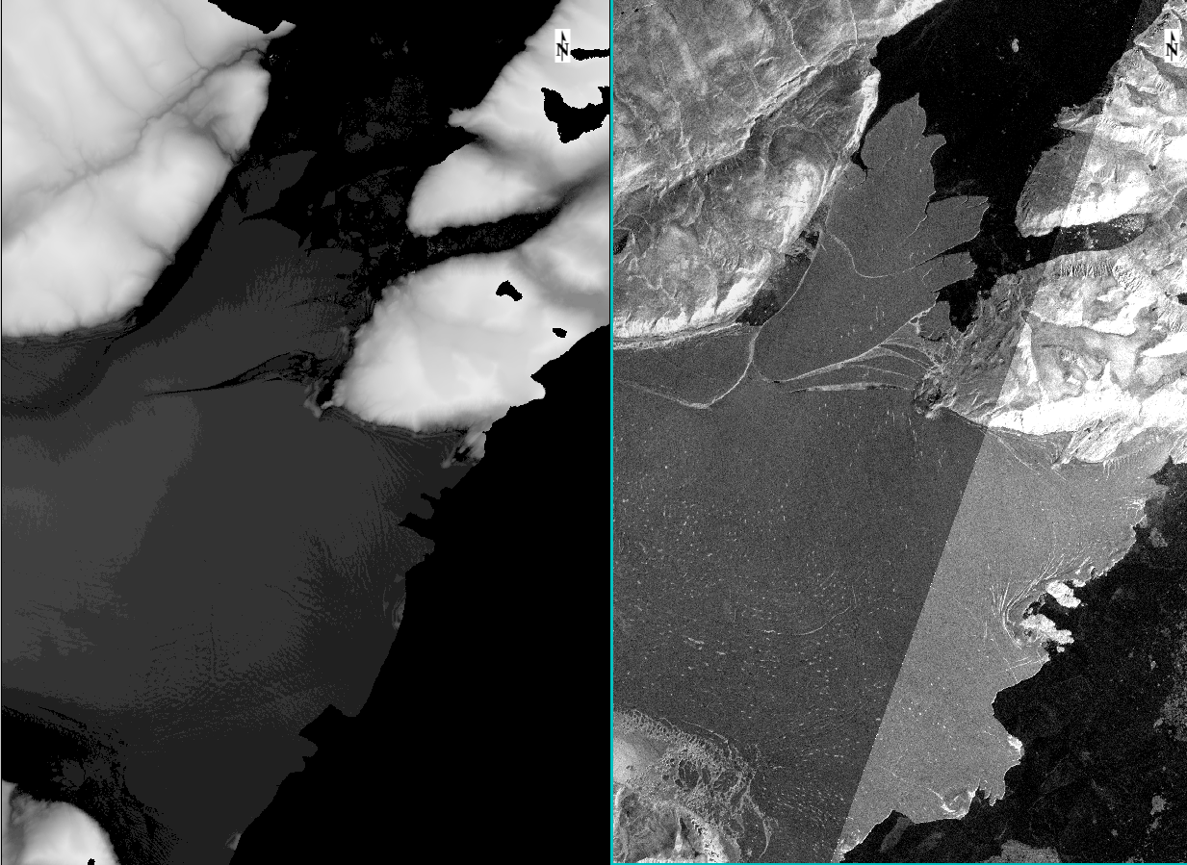

Figure 1: The study area of NG, NEGIS, Greenland. The image on the left is ALOS DSM: Global 30m digital surface model. The image on the right is the un-mosaicked Sentinel 1 L1 SRD IW mode HH image. The default map projection is WGS 84 / NSIDC EASE-Grid North. The upper outlet is named NG1 and the lower outlet is named NG2.

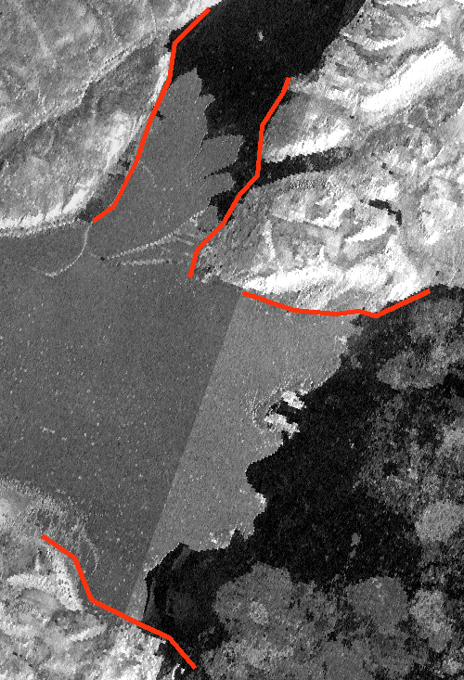

Figure 2: the edges that are paralleled to the flowing direction in the two sub-outlets.

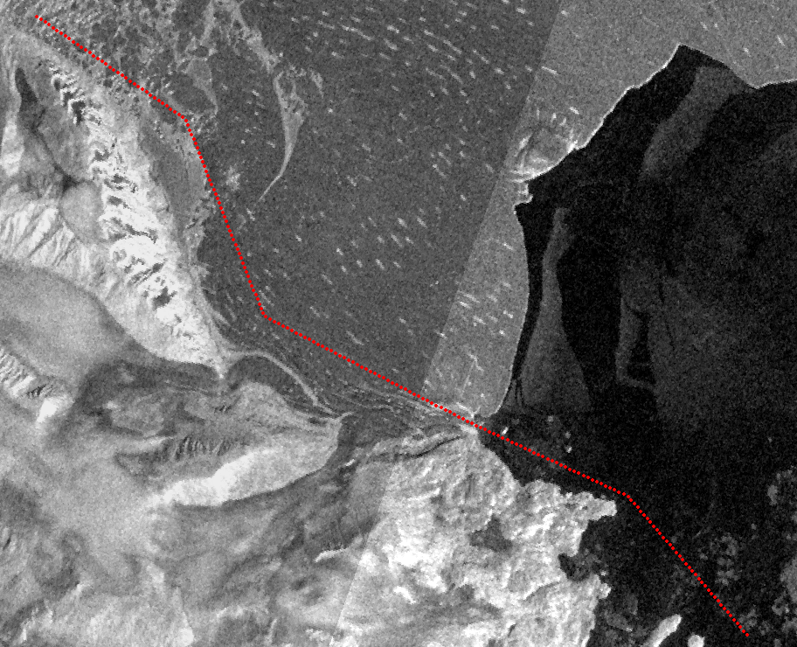

Figure 3: the series of points along one edge in NG2

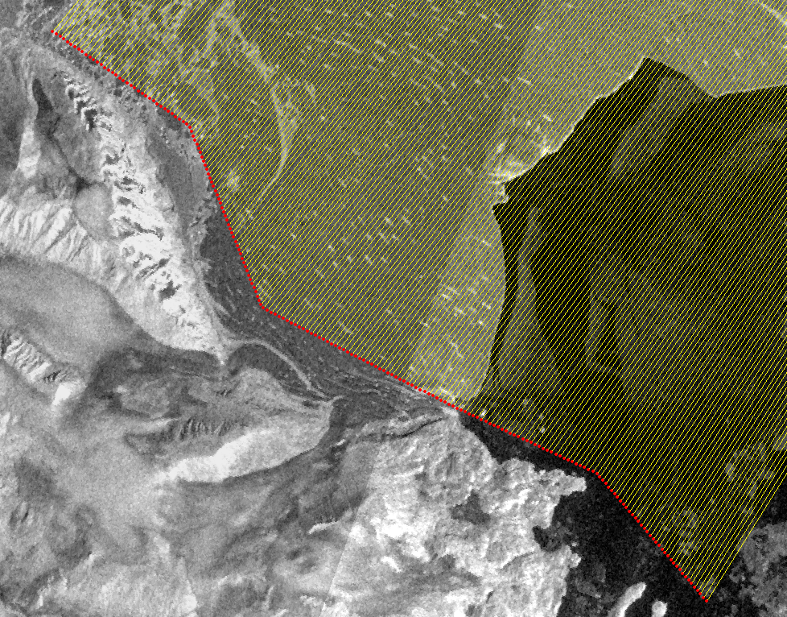

Figure 4: the lines constructed by 200 pairs of points

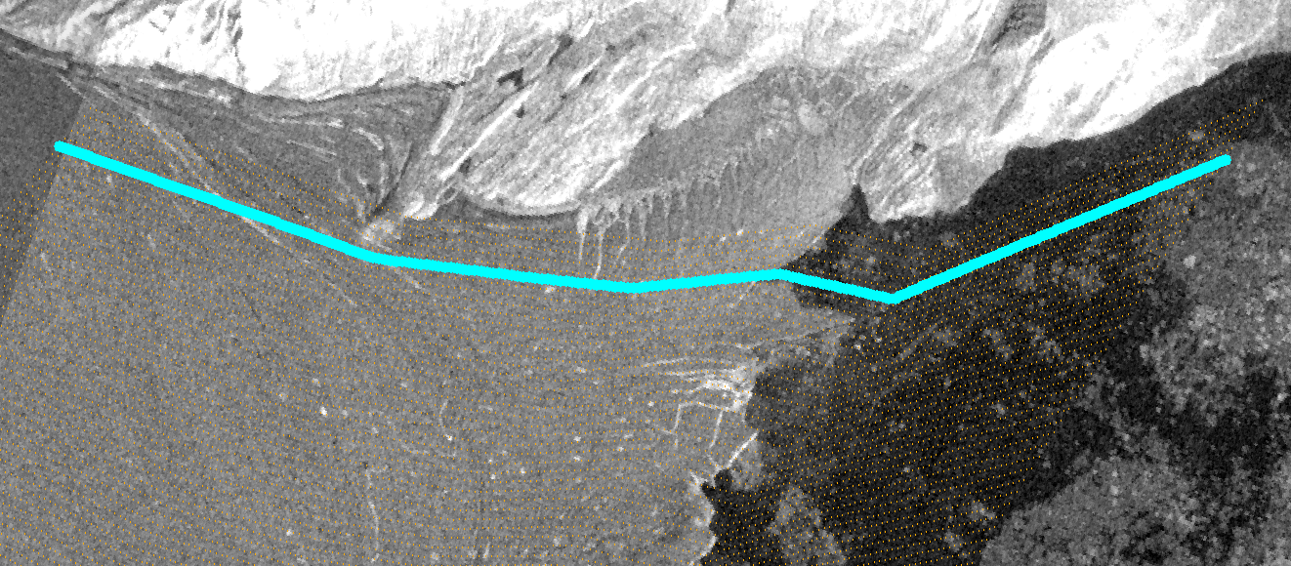

Figure 5: the mesh and the series of points with pid as 5 and flowid from 1 to 200, which indicates one profile in the mesh.

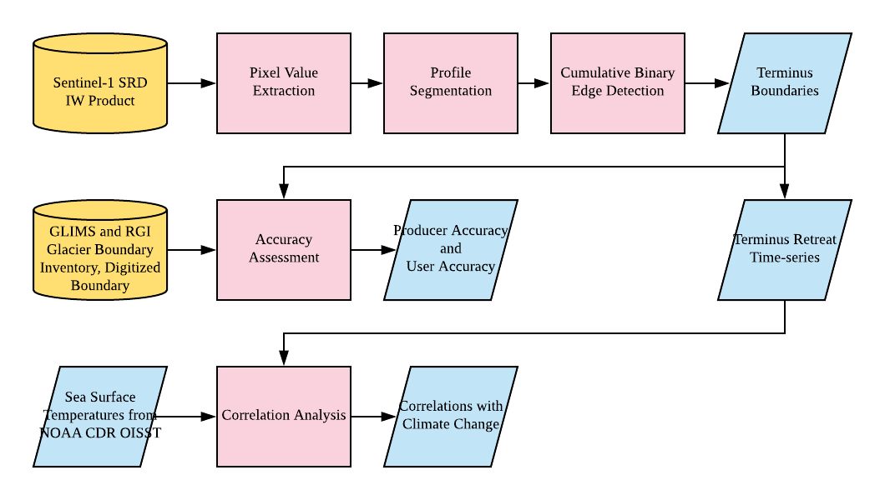

Figure 6: the workflow of glacier extent time-series analysis.

Results

The intensity threshold for separating open water and ice is determined in ENVI. First, an image of Sentinel-1 Level 1 C-band GRD product in September 2016 is loaded in ENVI. Then the Transect method in the profile analysis tool is used to draw a profile along the flowing direction. Figure 7 indicates that there is good separation between ice area and open water area, and the backscattering coefficient 18.5 can be a good candidate for the intensity threshold. After generating several profiles similar to Figure 7 in the study area, 18.5 is used as the intensity threshold.

To verify the use of 18.5 as intensity threshold, a script in GEE is used for testing different intensity thresholds. After many tests in different months, 14 becomes another candidate for the intensity threshold. According to Figure 8, the classification using 14 effectively removes sea ice from the image, but it creates speckles and holes among the patch of glaciers.

A manual digitized glacier terminus based on the sentinel 1 imagery in NG1 is used for accuracy assessment. According to Figure 9, the generated terminus has relatively high accuracy compared with the digitized boundary. However, the generated terminus recognizes some cracks around the edge as parts of the glacier, which leads to error in the classification. To investigate the difference between generated terminus and the digitized terminus, a verification polygon is created for identifying the accuracy of classification (Figure 10). The two termini cut the polygon into 4 categories including 4 classification results ([ice/snow, ice/snow], [ice/snow, water], [water, ice/snow], [water, water]). The result of accuracy assessment is shown in Table 1. The result indicates an overall accuracy of 94.30%, which indicates effective ice-water separation. Therefore, the quality of the terminus detection is relatively high.

The comparison between the generated terminus and RGI Glacier Inventory is not significant as the RGI data is not available in the study area (Figure 11).

The correlation between terminus location in NG1 and sea surface temperature is investigated, and the result of correlation analysis is shown in Table 2. According to the result, the correlation and the coefficient are both positive, which indicates a positive relationship between them, but the correlation is only 0.239, which indicates a low correlation between NG1 and sea surface temperature. According to the summary report for the linear model (Figure 11), the estimator “ng1” representing “flowid” or the relative position of the terminus position is not significant, and the adjusted R-squared value is 0.036, which is very far from 1, so the model does not perform well. The scatter plot with trend line of the linear model (Figure 13) displays that many points have high residuals from the trend line, so the model is not significant. According to Figure 14, the normal QQ plot shows that the residuals are not distributed normally, so there are systematic errors in the linear model, or the model is not significant for prediction.

Finally, the time-series of terminus detection are plotted. The terminus relative location or flowid is averaged for each month. The actual distance in meters from the solid starting point is flowid * 101.3 m. Figure 15 and 16 displays the time series in NG1. Figure 17 and 18 displays the time series in NG2. The time-series of sea surface temperature is shown in Figure 19, which provides a reference for the time-series of ice front position in NG.

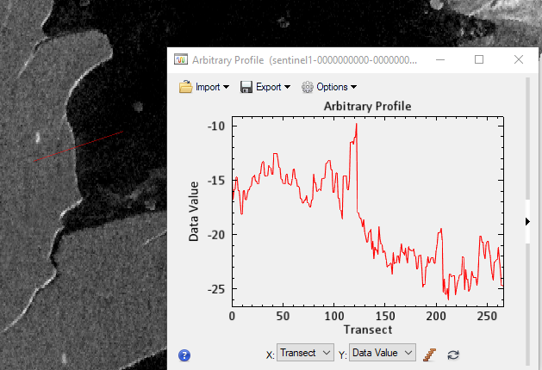

Figure 7: an example of an Arbitrary Profile result in ENVI.

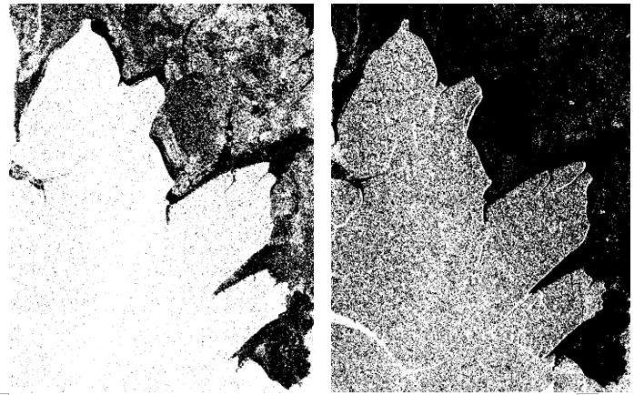

Figure 8: the screenshot of classification result using 18.5 (left) and 14 (right) as intensity threshold in September 2015.

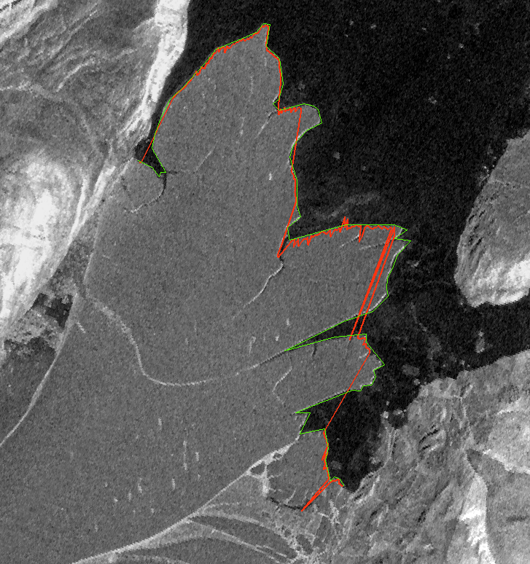

Figure 9: the generated terminus (red line) compared with the digitized terminus (green line).

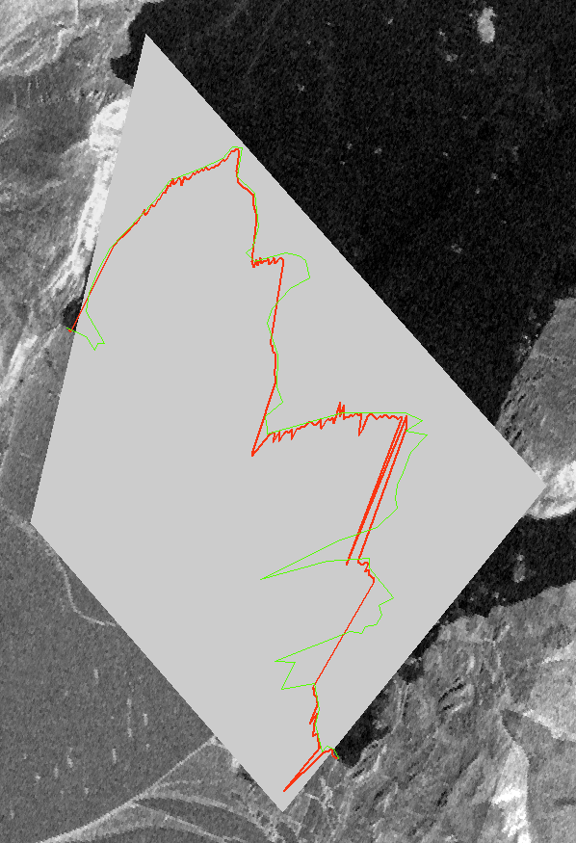

Figure 10: The verification polygon for generating the accuracy assessment.

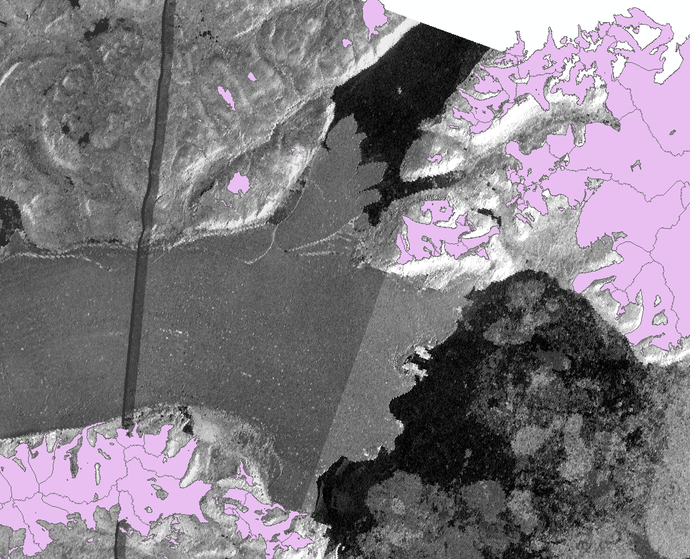

Figure 11: the available RGI glacier boundary data (the pink polygons) are not overlapped with the terminus.

Table 1: The accuracy assessment report. The column name represents the digitized classification result as referenceThe row name represents the generated classification result. The unit is km2.

|  |  |  |  |
| --- | --- | --- | --- |
| Referenced  Produced | Snow/Ice | Open Water | Total |
| Snow/Ice | 59.722 | 2.934 | 62.656 |
| Open Water | 2.037 | 33.697 | 35.734 |
| Total | 61.759 | 36.631 | 98.390 |
| Snow/Ice Producer Accuracy: 94.30%  Snow/Ice User Accuracy: 95.32%  Overall Accuracy: 94.95% | | | |

Table 2: The linear correlation analysis between sea surface temperature and terminus location.

|  |  |  |  |
| --- | --- | --- | --- |
|  | Intercept | Coefficient | Correlation |
| Value | -200.988 | 0.744 | 0.239 |

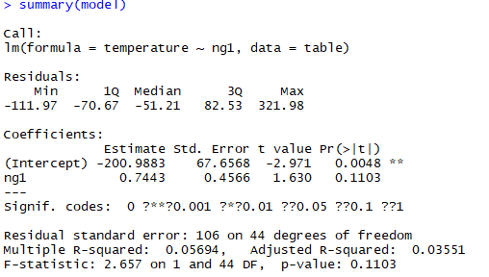

Figure 12: the summary report of the linear model between sea surface temperature and terminus location.

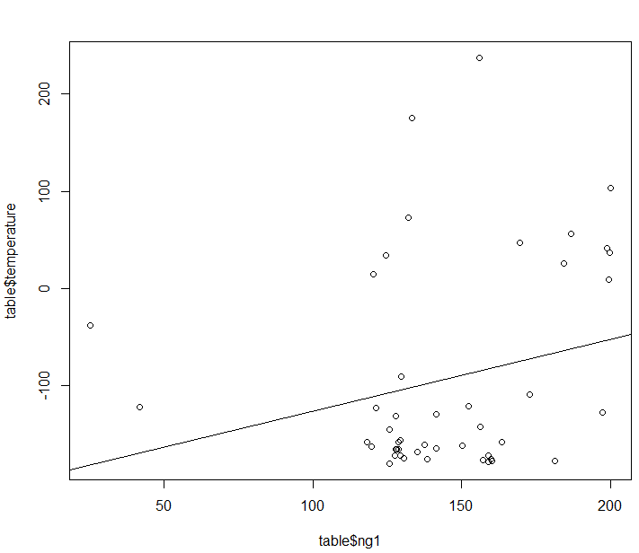

Figure 13: the scatter plot with trend lines of the linear model

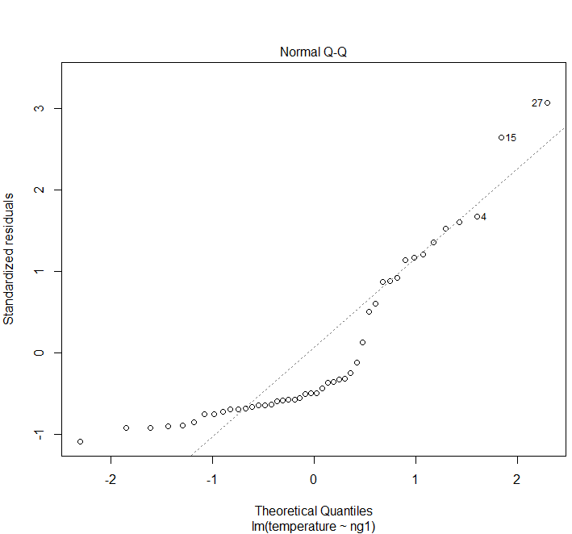

Figure 14: the normal QQ plot displaying the error distribution.

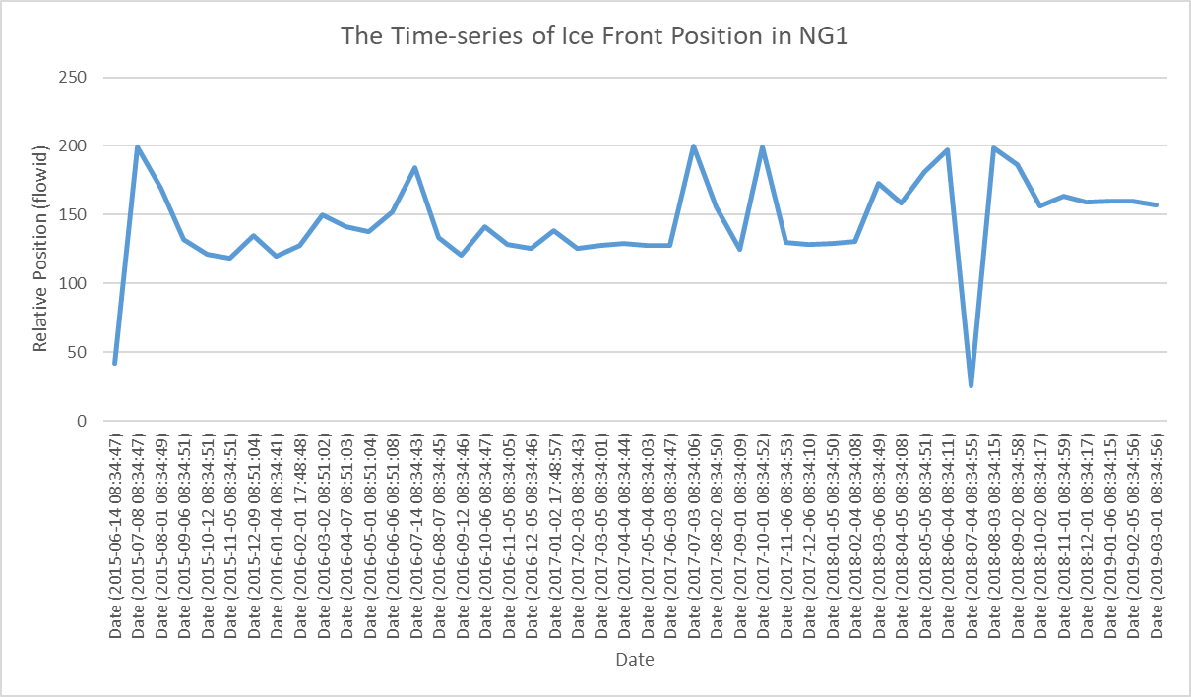

Figure 15: The time-series of terminus position in NG1.

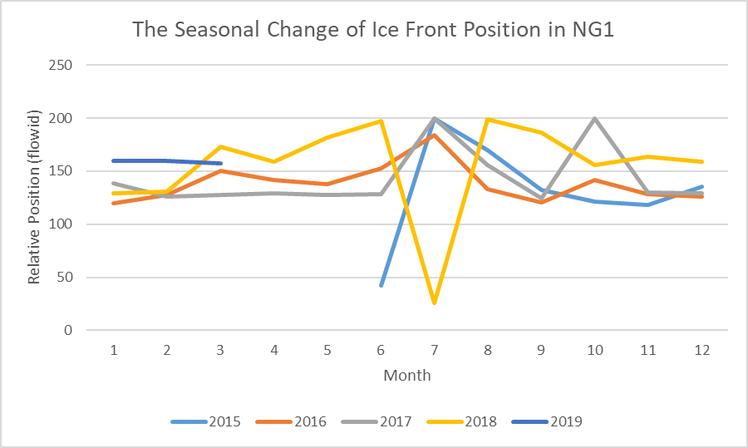

Figure 16: The inter-annual trend of terminus position in NG1

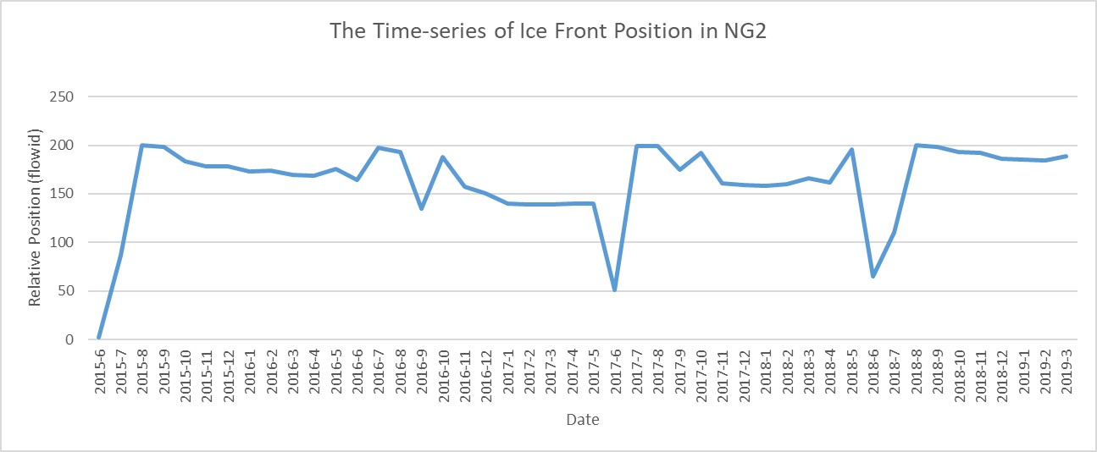

Figure 17: The time-series of terminus position in NG2.

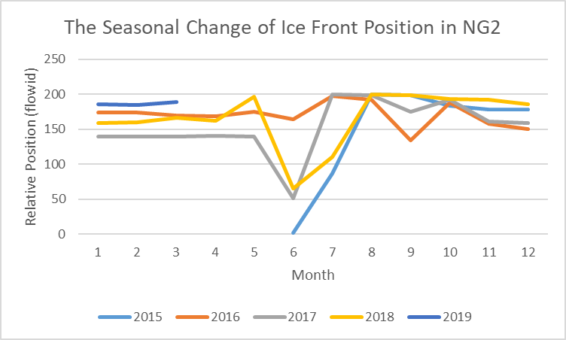

Figure 18: The inter-annual trend of terminus position in NG2

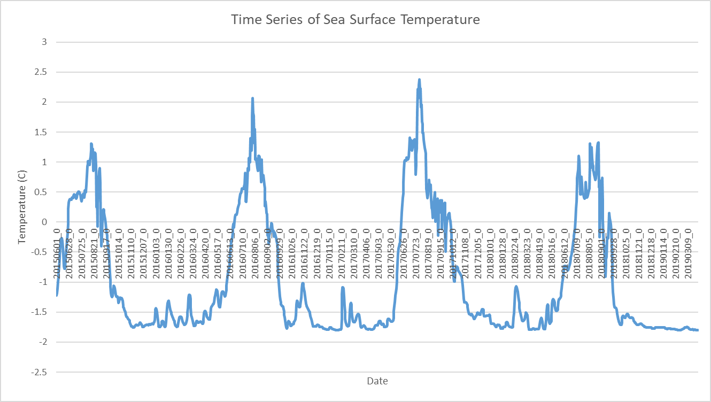

Figure 19: the time series of sea surface temperature.

Discussion

The time series reveals similar inter-annual and annual pattern of the terminus position.

NG1 and NG2 has similar annual trend. The terminus positions are both lowest in 2017 and are both highest in 2019 in NG1 and NG2, and their position are both decreasing from 2015 to 2017 and then are both increasing from 2017 to 2019 (Figure 15, Figure 17). The average position in 2017 for NG1 is around 125, and the one for NG2 is around 145. From 2017 to 2018, both of the positions increase. NG1 increases to 130, and NG2 increases to 155. From 2018 to 2019, the two positions increase simultaneously as well. NG1 increases to 155 and NG2 increases to 190. Therefore, NG1 and NG2 has the same retreat/advance pattern. Moreover, the termini in NG do not retreat completely but bounce around a certain position. For NG1, the average position is around 130, and it is around 155 in NG2. On the other hand, for the inter-annual trends (Figure 16, Figure 18), the two outlets both show instability around June and July, displaying either very high position or very low position. According to the images in June and July (Figure 20), the cover snow on the glacier melts during the period so that the backscattering is greatly reduced, and ice calving at the edge is more frequent, which leads to difficulty separating glacier and water.

The relative terminus position of NG1 is more unstable than NG2. NG1 has high fluctuation over the whole year (Figure 16), but NG2 only has high fluctuation between June and October (Figure 18). One of the possible reason is that the ice calving in NG1 is more active than NG2 between 2015 and 2019, so there are more cracks and calving ices in the area of NG1 (Figure 1, Figure 20).

Continuous monitoring of NG is required to understand the annual and inter-annual pattern of terminus retreat. As the Sentinel 1 data is only available for 5 years, it is not sufficient to fully uncover the pattern of glacier retreat in NG. The patterns identified above may only accounts for a small vibration in the long-term pattern. Therefore, it is necessary to continue to monitor the position of glacier terminus to uncover the long-term pattern and its relation to climate change.

The terminus extraction method using Sentinel 1 data, GEE and mesh-based profile method provides an effective way for long-term and large-scale glacier extent monitoring in any study area in the world. Sentinel 1 data is ideal for identifying glacier boundary. It is available from 2014 till present, and it have high spatial resolution, high temporal resolution and global coverage. Moreover, SAR imagery are effective for classifying ice and open water as ice has high backscattering coefficient, but water has low backscattering coefficient. Moreover, Sentinel 1 data is available in GEE, and the mesh for profiling can be generated easily in any location on Earth. GEE can finish the pixel extraction request for around 5 min for 39800 points, which allows data to be exported and downloaded effectively. The edge detection takes around 4 hours to finish using personal laptop, but the speed will increase significantly using industry-based computing power and cloud computing techniques. Finally, the trend analysis and the accuracy assessment also indicate high terminus detection accuracy from November to April, which will be useful for quantitative research. In conclusion, the terminus extraction method is effective for long-term and large-scale glacier extent monitoring.

The seasonal fluctuation of sea surface temperature may not influence the position of glacier terminus. According to Figure 19, the time series of sea surface temperature does not change significantly between years, and the inter-annual change between June and September is not significant enough for large ice calving, so it may not influence the position of glacier front.

The low correlation between terminus position and sea surface temperature may be caused by misinterpreting the internal ice dynamics within the glacier. As climate change increases ice calving, it can also increase the velocity of glacier. The increase in glacier velocity may cause the terminus to advance. Therefore, to fully understand the relationship between glacier front position and climate change, it is necessary to identify the correlation between glacier velocity and climate change.

Conclusion

NEGIS is a study area suffering from large ice calving events in the 2010s. It is significant to investigate on the change of glacier extent especially the change of termini in that area. To investigate the relationship between glacier extent and climate change, a mesh-based profile method using Sentinel 1 data and GEE is used for creating time series of terminus location in NG, NEGIS. An accuracy assessment is conducted to analyze the accuracy of the ice front detection, which reveals relatively high accuracy compared with the digitized result. The time series reveals significant annual and inter-annual pattern of the change of terminus. The result also indicates that the two outlets have their own characteristics. The sea surface temperature data is retrieved to identify the relationship between terminus position and climate. A correlation analysis using linear model is used, which shows low correlation between the two sets of data. In summary, the terminus detection workflow provides an effective method for long-term and large-scale glacier monitoring, and it reveals significance for further monitoring in the area of NG, NEGIS. Further studies can focus on identifying the correlation between glacier velocity and climate change.

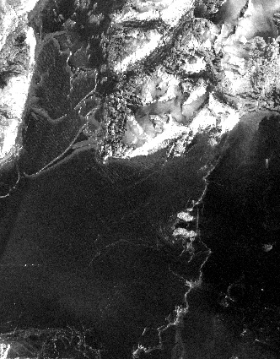

Figure 20: a sample sentinel 1 image in the study area in June 2016.

References

Abdalati, W., Krabill, W., Frederick, E., Manizade, S., Martin, C., Sonntag, J. et al. & Yungel, J. (2001). Outlet glacier and margin elevation changes: Near‐coastal thinning of the Greenland ice sheet. Journal of Geophysical Research: Atmospheres, 106(D24), 33729-33741.

Benn, D., & Evans, D. J. (2014). Glaciers and glaciation. Routledge.

Denton, G. H., & Hughes, T. J. (Eds.). (1981). The last great ice sheets. Wiley.

Gramling, Carolyn. (2015). Rapid melting of Greenland glacier could raise sea levels for decades. Science. 10.1126/science.aad7431.

Han, L., Floricioiu, D., Baessler, M., & Eineder, M. (2016, July). An algorithm for the detection of calving glaciers frontal position from TerraSAR-X imagery. In 2016 IEEE International Geoscience and Remote Sensing Symposium (IGARSS) (pp. 6171-6174). IEEE.

Joughin, I., Howat, I., Alley, R. B., Ekstrom, G., Fahnestock, M., Moon, T., ... & Tsai, V. C. (2008). Ice‐front variation and tidewater behavior on Helheim and Kangerdlugssuaq Glaciers, Greenland. Journal of Geophysical Research: Earth Surface, 113(F1).

Koerner, R. M. (1980). Instantaneous glacierization, the rate of albedo change, and feedback effects at the beginning of an Ice Age. Quaternary Research, 13(2), 153-159.

Lemmen, D. S., Evans, D. J. A., & England, J. (1988). Canadian Landform Examples 10: ice shelves of northern Ellesmere Island, NWT. Canadian Geographer, 32, 363-367.

Larsen, Levy, Carlson, Buizert, Olsen, Strunk, Skov. (2018). Instability of the Northeast Greenland Ice Stream over the last 45,000 years. Nature Communications, 9(1), 1-8.

Li, F., Wang, Z., Zhang, S., & Zhang, Y. (2018). GLACIER FRONTAL LINE EXTRACTION FROM SENTINEL-1 SAR IMAGERY IN PRYDZ AREA. International Archives of the Photogrammetry, Remote Sensing & Spatial Information Sciences, 42(3).

Oerlemans, J. (1994). Quantifying global warming from the retreat of glaciers. Science, 264(5156), 243-245.

Seale, A., Christoffersen, P., Mugford, R. I., & O'Leary, M. (2011). Ocean forcing of the Greenland Ice Sheet: Calving fronts and patterns of retreat identified by automatic satellite monitoring of eastern outlet glaciers. Journal of Geophysical Research: Earth Surface, 116(F3).

Sole, A., Payne, T., Bamber, J., Nienow, P., & Krabill, W. (2008). Testing hypotheses of the cause of peripheral thinning of the Greenland Ice Sheet: is land-terminating ice thinning at anomalously high rates?. The Cryosphere, 2(2), 205-218.

Wood, Rignot, Fenty, Menemenlis, Millan, Morlighem, et al. (2018). Ocean‐Induced Melt Triggers Glacier Retreat in Northwest Greenland. Geophysical Research Letters, 45(16), 8334-8342.